Project Documentation

Cookbook:Your virtual kitchen assistant

# 1. Introduction

* Project title : cookbook: your virtual kitchen assistant
* Team ID:NM2025TMID47720
* Team Leader: NIVETHA K & [nivetha84280@gmail.com](mailto:nivetha84280@gmail.com)

## Team members:

MONIKA C & [moni. ammu.0818@gmail.com](mailto:moni.%20ammu.0818@gmail.com)

NANDHINI V & [nandhini200628@gmail.com](mailto:nandhini200628@gmail.com)

PAVITHRA K & [pavira0987@gmail.com](mailto:pavira0987@gmail.com)

# 2. Project overview

* Purpose:

Cookbook is a web application designed to revolutionize the way users discover organize and create recipes.Users can browser save and manage their favourite recipes with detailed instructions and ingredient lists.

* features

-Recipe recommendation

-Step by step guidance

- Ingredient substitution

-Bookbook feature for favourite recipe

# 3 . Architecture:

## Component structure:

This application is divided into components,pages;and styles.

Components: Reusable UI elements like Navbar,Hero,Footer, and Newsletter

Pages : Home,category and Recipes pages that represent different URL routes.

Styles:CSS files for styling each component and page.

# 4 . Setup instructions

--Node.js

--MongoDB

--Git

--React.js.

--Express.js-Mongoose-Visual Studio Code

## Installation steps:

#Clone the repository git glone

#Install client dependencies cd Client npm install

#nstall server dependencies cd ../server npm install

# 5. Folder structure

recipe-app-react/

├── node-modules/

├── public/

├── src/

│ ├── components/ # Reusable UI Components

│ │ ├── Navbar.jsx

│ │ ├── Hero.jsx

│ │ ├── categories Home.jsx

│ │ ├── Footer.jsx

│ │ ├── Newsletter.jsx

│ ├── pages/ # Page Components

│ │ ├── Home.jsx

│ │ ├── Category.jsx

│ │ ├── Recipe.jsx

│ ├── styles/ # CSS Files

│ │ ├── Home.css

│ │ ├── Navbar.css

│ │ ├── Recipe.css

├── App.js

├── index.js

├── package.json

# 6.Running the application

## Frontend:

Cd client

Npm start

## Backend:

Cd sever npm start

### Access: Visit <http://localhost:3000>

# 7.API Documentation

## Key components:

* Navbar:provdesnavigationlins to differen tpages. Hero Dsplays a brief description of the app and a call to action button. Categories Home Displays popular recipe categories fetched from the mealsDB API Recipe Displays detailed information including ingredients,instructions,and a tutorial video

# 8.Authentication

When a user registers the system generates a unique API key client stores it securely

# 9.User interface

## Home page

Displays popular categories and trending dishes

## Category page

Lists all dishes under a specific category

## Recipe page

Shows detailed recipe information including ingredients instructions,and a video tutorial.

# 10.Testing

## Testing strategy

Jest for unit testing react testing library for component testing

## Code coverage:

Ensured high test coverage with jest reports

# 11.screenshots or demo:

6. Running the Application:

Frontend:

•Start the development server:

¬npm start

•The application will be available at

¬http://localhost:3000 .

7. Component Documentation:

Key Components:

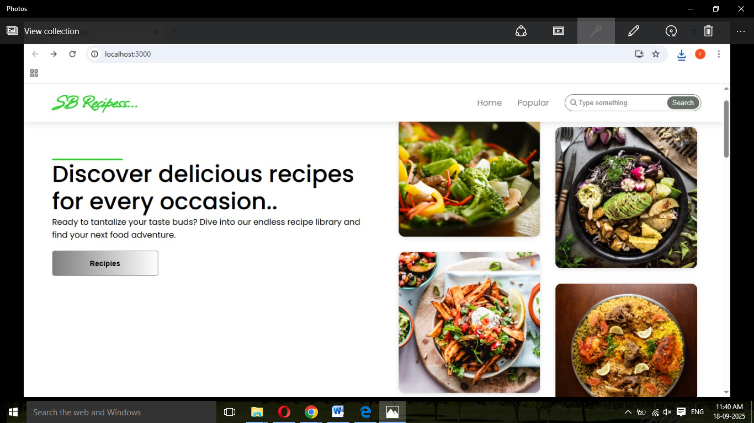Frontend:

•Start the development server:

¬npm start

•The application will be available at

¬http://localhost:3000 .

7. Component Documentation:

Key Components:

6. Running the Application:

Frontend:

•Start the development server:

¬npm start

•The application will be available at

¬http://localhost:3000 .

7. Component Documentation:

Key Components

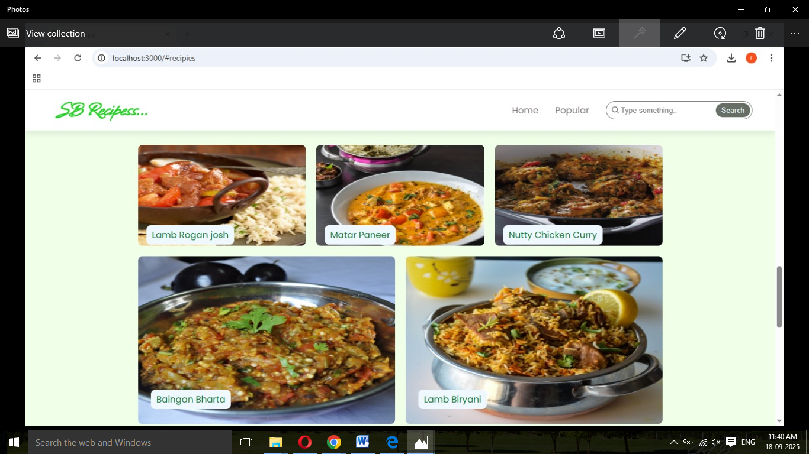

# 12.known issues

* Certain API end points may experience delays peak traffic ingredientchecklist feature may require further optimization

# 13.future enhancements

AI based recipe suggestions

User Authentication for personalized recipe collections

Integration with grocery shopping platforms

Offline mode for accessing saved recipes

## 14.Existing solution: https://github.com/nivetha200608/cookbook.git